A project report
On
PROJECT TITLE
Submitted to
IILM UNIVERSITY
In Partial Fulfilment for the award of the degree of
B.TECH
In
COMPUTER SCIENCE AND ENGINEERING
By
VAIBHAV TRIPATHY
25SCS1003005357
Under the guidance of
VARSHA SRIVSTAVA
Assistant Professor


IILM UNIVERSITY,
16-18, Knowledge Park II,
Greater Noida
Uttar Pradesh 201306

February 2026

DECLARATION

I declare that the project entitled “_______________________” has been prepared by me under the guidance of “________________________”, No part of this project has formed the basis for the award of any degree or fellowship previously.

VAIBHAV TRIPATHY
25SCS1003005357

CERTIFICATE

This is to certify that the project report titled “Food Waste Analysis” submitted by Vaibhav Tripathy (Enrollment No.: 25SCS1003005357), a student of B.Tech Computer Science and Engineering at IILM University, Greater Noida, is a bonafide record of the work carried out by him during the academic session 2025–2026.
The work presented in this report has been completed under my supervision and guidance. To the best of my knowledge, this project has not been submitted elsewhere for the award of any degree or diploma.
This project fulfills the requirements of the course and demonstrates satisfactory work in the field of data analysis.
Project Guide:
Varsha Srivastava
Signature of Guide: ______________________
Head of Department: ______________________
Date: ______________________
Place: Greater Noida

ABSTRACT

Food waste is a major global concern that impacts both environmental sustainability and economic efficiency. A significant portion of food produced is wasted due to improper planning, over-preparation, poor storage practices, and lack of awareness. This project aims to analyze food waste behavior using a data-driven approach to identify key causes and suggest effective solutions.
The dataset used in this study was collected through a structured survey conducted using Google Forms, consisting of 100 responses from students and households. The collected data includes information related to food purchasing habits, consumption patterns, leftover management, and reasons for food waste.
The dataset was preprocessed and analyzed using tools such as Microsoft Excel and Python. Data cleaning techniques were applied to remove missing and duplicate values, followed by exploratory data analysis and visualization to identify patterns and trends.
The results of the analysis indicate that overcooking and improper food management are the primary causes of food waste. It was also observed that although many individuals prefer to consume leftovers, a significant portion still discards food, highlighting the gap between awareness and practice.
The findings of this project emphasize the importance of data-driven decision-making in reducing food waste. By implementing simple strategies such as proper meal planning, improved storage methods, and awareness, food waste can be significantly minimized. This study provides a foundation for future work involving advanced predictive models and real-time monitoring systems.

ACKNOWLEDGMENT

I would like to express my sincere gratitude to my project guide, Varsha Srivastava, for her valuable guidance, continuous support, and encouragement throughout the completion of this project titled “Food Waste Analysis”. Her insights and suggestions greatly helped in shaping this work in a structured and effective manner.
I am also thankful to IILM University, Greater Noida, for providing the necessary resources and academic environment to successfully carry out this project.
I would like to extend my appreciation to all the respondents who participated in the survey and contributed their valuable data, which formed the foundation of this analysis.
Finally, I would like to thank my friends and peers for their support and cooperation during the development of this project.

TABLE OF CONTENTS
DECLARATION ii
CERTIFICATE iii
ABSTRACT v
ACKNOWLEDGMENT vi
TABLE OF CONTENTS vii
LIST OF FIGURES viii
LIST OF TABLES ix
LIST OF ALGORITHMS x
LIST OF ABBREVIATIONS xi

- INTRODUCTION
- LITERATURE STUDY
- DATASET PREPARATION AND PRE-PROCESSING
- Methodology & Novelty
- EXPERIMENTAL RESULTS AND DISCUSSION
- CONCLUSIONS AND FUTURE DIRECTIONS
REFERENCES

LIST OF FIGURES
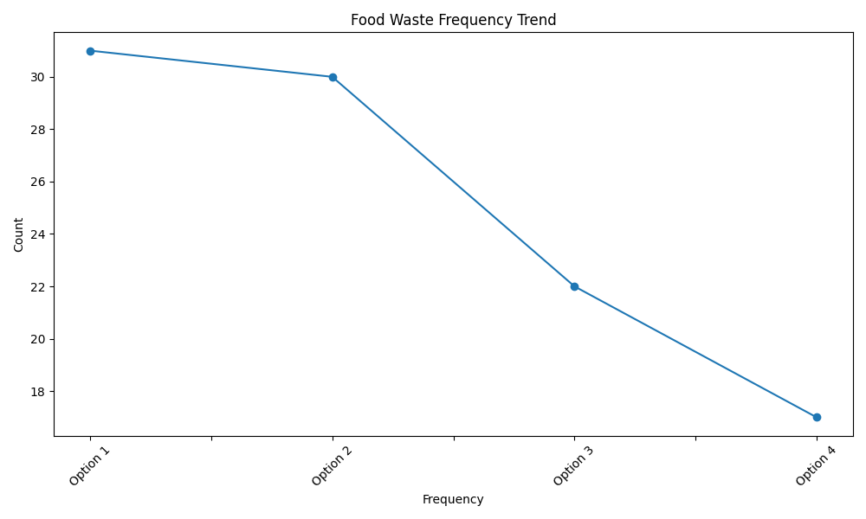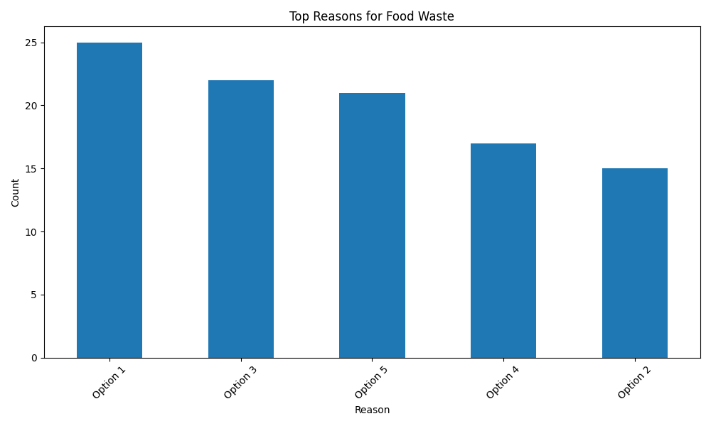

LIST OF TABLES
Table No. | Title of Table | Page No.
Table 2.1 | Details of Survey Questionnaire | ___
Table 2.2 | Raw Data Collected from Students | ___
Table 2.3 | Preprocessed (Cleaned) Dataset | ___
Table 3.1 | Food Consumption Patterns of Students | ___
Table 3.2 | Quantity of Food Waste Generated | ___
Table 3.3 | Reasons for Food Wastage | ___
Table 3.4 | Meal Type vs Food Waste Analysis | ___
Table 4.1 | Statistical Summary of Data | ___
Table 4.2 | Correlation between Variables | ___
Table 4.3 | Weekly/Monthly Food Waste Trends | ___
Table 5.1 | Output Results / Analysis Findings | ___

LIST OF ALGORITHMS
Algorithm No. | Name of Algorithm | Page No.
Algorithm 1.1 | Data Collection using Google Forms | ___
Algorithm 2.1 | Data Cleaning and Preprocessing | ___
Algorithm 2.2 | Handling Missing Values | ___
Algorithm 2.3 | Encoding Categorical Data | ___
Algorithm 3.1 | Exploratory Data Analysis (EDA) | ___
Algorithm 3.2 | Food Waste Pattern Analysis | ___
Algorithm 4.1 | Statistical Analysis (Mean, Median, Mode) | ___
Algorithm 4.2 | Correlation Analysis | ___
Algorithm 5.1 | Prediction Model (if implemented) | ___

LIST OF ABBREVIATIONS

Abbreviation | Full Form
AI | Artificial Intelligence
ML | Machine Learning
EDA | Exploratory Data Analysis
CSV | Comma Separated Values
KPI | Key Performance Indicator
WHO | World Health Organization
FAO | Food and Agriculture Organization
SDG | Sustainable Development Goals
GUI | Graphical User Interface
API | Application Programming Interface
IoT | Internet of Things
Kg | Kilogram
Avg | Average
No. | Number

CHAPTER-1

INTRODUCTION
Food waste has become a major global concern affecting both economic stability and environmental sustainability. A significant portion of food produced is lost or wasted due to inefficient consumption patterns, improper storage, and over-preparation. This not only results in financial losses but also contributes to environmental issues such as increased greenhouse gas emissions and resource depletion.
In recent years, there has been growing awareness about the importance of reducing food waste through better planning and data-driven decision-making. Understanding the behavior and habits that lead to food wastage is essential for developing effective solutions.
This project, titled “Food Waste Analysis”, focuses on analyzing food waste patterns using data collected through a structured survey. The dataset includes responses from students and households, providing insights into their food purchasing, consumption, and disposal habits.
By applying data cleaning techniques and basic data analysis methods, the study aims to identify the primary causes of food waste and suggest practical recommendations to minimize it. The findings of this project can help in promoting efficient resource utilization and encouraging sustainable practices.

CHAPTER-2

LITERATURE STUDY
Food waste has been widely studied as a critical issue affecting both environmental sustainability and economic efficiency. According to the Food and Agriculture Organization (FAO), approximately one-third of the food produced globally is lost or wasted every year. This highlights the urgent need for effective strategies to reduce food wastage.
Several researchers have analyzed food waste behavior using survey-based methods. These studies identified key causes of food waste, including overcooking, improper storage, lack of awareness, and food expiry. Surveys conducted among households and students show that behavioral patterns play a significant role in food wastage.
Previous studies have also used statistical and data analysis techniques to understand food consumption trends. Tools like Microsoft Excel and Python have been widely used for data cleaning, visualization, and pattern identification. Visualization techniques such as bar charts and pie charts help in identifying major contributors to food waste.
In recent years, there has been a shift towards using machine learning models to predict food waste patterns. However, many of these studies are limited due to small dataset sizes and lack of real-time data. Additionally, most research focuses either on households or commercial sectors, with limited studies combining both perspectives.
Furthermore, awareness campaigns and sustainable practices have been suggested as effective measures to reduce food waste. Educating people about proper food storage, portion control, and reuse of leftovers has shown positive results in minimizing waste.
Despite these advancements, there is still a gap in integrating data-driven approaches with real-world behavior analysis. This project aims to bridge that gap by analyzing survey data and providing practical insights for reducing food waste.

CHAPTER-3

DATASET PREPARATION AND PRE-PROCESSING
3.1 Dataset Preparation
The dataset for this project was collected using an online survey created through Google Forms. The survey was distributed among students and households to gather information about their food consumption, storage habits, and waste patterns.
A total of 100 responses were collected, providing a diverse set of behavioral data. The dataset includes:
- Food purchasing habits
- Quantity of food prepared
- Leftover handling practices
- Reasons for food waste
- Frequency of food wastage
The responses were automatically recorded and exported into a spreadsheet format for further analysis using Microsoft Excel.

3.2 Data Preprocessing
Data preprocessing is a crucial step to ensure the quality and reliability of the dataset before analysis. The following steps were performed:
1. Data Cleaning
- Removed incomplete or missing responses
- Eliminated duplicate entries
- Checked for inconsistent or incorrect values
2. Data Transformation
- Converted categorical responses (e.g., “Often”, “Rarely”) into structured formats
- Standardized data entries for uniformity
3. Data Formatting
- Organized data into rows and columns
- Renamed columns for better understanding
- Ensured consistent data types
4. Data Validation
- Verified accuracy of responses
- Ensured no irrelevant or noisy data was present

3.3 Tools Used
- Microsoft Excel – for data organization and initial cleaning
- Python (with Pandas & NumPy) – for preprocessing and data handling

3.4 Importance of Preprocessing
Proper preprocessing improved:
- Accuracy of analysis
- Data consistency
- Reliability of results
It ensured that the dataset was clean, structured, and ready for Exploratory Data Analysis (EDA) and further modeling.

CHAPTER -4

Methodology & Novelty
4.1 Methodology
The methodology adopted in this project follows a systematic and structured approach to analyze food waste patterns using data-driven techniques.
4.1.1 Data Collection
The data was collected through a Google Form survey distributed among students and households. The questionnaire focused on food purchasing habits, consumption patterns, storage practices, and reasons for food wastage.

4.1.2 Data Preparation
The collected responses were exported into a spreadsheet using Microsoft Excel. The dataset was organized into a structured format with proper rows and columns for easy analysis.

4.1.3 Data Preprocessing
Data preprocessing was performed to ensure accuracy and consistency. The steps included:
- Removal of missing and incomplete responses
- Elimination of duplicate entries
- Standardization of categorical data
- Formatting and structuring of dataset

4.1.4 Exploratory Data Analysis (EDA)
Exploratory Data Analysis was conducted to identify patterns and trends in food waste behavior. This included:
- Analyzing reasons for food waste
- Studying leftover handling practices
- Observing consumption and preparation patterns

4.1.5 Data Visualization
Visualization techniques were used to present the data in an understandable form. Graphs and charts were created using:
- Microsoft Excel
- Python (Matplotlib)
These visualizations helped in identifying key patterns and trends.

4.1.6 Interpretation of Results
The analyzed data was interpreted to extract meaningful insights about food waste causes and behaviors. This step helped in understanding the major contributors to food wastage.

4.1.7 Recommendations
Based on the findings, practical recommendations were provided to reduce food waste and improve resource utilization.
4.2 Novelty of the Project
The project introduces several innovative aspects that differentiate it from existing studies:
4.2.1 Combined Data Approach
This study includes responses from both students and households, providing a broader and more realistic perspective.

4.2.2 Behavior-Based Analysis
Focuses on real-life habits such as overcooking, food storage, and leftover management instead of only theoretical data.

4.2.3 Data-Driven Decision Making
Uses structured data analysis and visualization to derive insights rather than relying on assumptions.

4.2.4 Practical Implementation
Provides simple and actionable recommendations that can be applied in daily life to reduce food waste.

4.2.5 Future Scope for Machine Learning
The prepared dataset can be used in future to develop predictive models for food waste forecasting.

CHAPTER-5

EXPERIMENTAL RESULTS AND DISCUSSION

4.2 Novelty of the Project
The project introduces several innovative aspects that differentiate it from existing studies:

4.2.1 Combined Data Approach
This study includes responses from both students and households, providing a broader and more realistic perspective.

4.2.2 Behavior-Based Analysis
Focuses on real-life habits such as overcooking, food storage, and leftover management instead of only theoretical data.

4.2.3 Data-Driven Decision Making
Uses structured data analysis and visualization to derive insights rather than relying on assumptions.

4.2.4 Practical Implementation
Provides simple and actionable recommendations that can be applied in daily life to reduce food waste.

4.2.5 Future Scope for Machine Learning
The prepared dataset can be used in future to develop predictive models for food waste forecasting.

CHAPTER-6

CONCLUSIONS AND FUTURE DIRECTIONS

6.1 Conclusion
This project, “Food Waste Analysis”, successfully analyzed food waste behavior using survey-based data collected from students and households. The study identified that overcooking, improper storage, and lack of planning are the primary causes of food wastage.
Through data preprocessing, analysis, and visualization using tools like Microsoft Excel and Python, meaningful insights were derived regarding food consumption and waste patterns. The results clearly indicate that food waste is largely influenced by human behavior and inefficient management practices.
The project also demonstrates that adopting data-driven approaches can help in understanding and reducing food waste effectively. By implementing simple strategies such as portion control, better storage methods, and awareness, food waste can be significantly minimized.
Overall, this study highlights the importance of combining data analysis with practical solutions to address real-world problems like food wastage.

6.2 Future Direction
Although the project provides useful insights, there is scope for further improvement and expansion in the future:
6.2.1 Larger Dataset
- Collect data from a larger and more diverse population
- Include different regions and demographics for better accuracy

6.2.2 Advanced Machine Learning Models
- Apply predictive models to forecast food waste
- Use algorithms to suggest optimal food preparation quantities

6.2.3 Real-Time Data Integration
- Develop systems to track food waste in real-time
- Use IoT-based solutions for monitoring food storage

6.2.4 Inclusion of Additional Factors
- Consider external factors such as:
  - Weather conditions
  - Seasonal demand
  - Economic factors

6.2.5 Application Development
- Create a mobile/web application to:
  - Track food consumption
  - Suggest meal planning
  - Reduce food wastage

6.2.6 Awareness and Implementation
- Conduct awareness campaigns
- Implement solutions at college or community level

REFERENCES

- Food and Agriculture Organization (FAO). Global Food Losses and Food Waste Report.
- United Nations Environment Programme (UNEP). Food Waste Index Report.
- Survey Data collected through Google Forms (Primary Data Source).
- Microsoft Excel – Used for data collection, organization, and basic analysis.
- Python (with Pandas, NumPy, Matplotlib) – Used for data preprocessing and visualization.
- Research articles on food waste management and sustainability (various academic sources).
- Online educational resources and tutorials related to data analysis and food waste studies.

